# Site Map

# 

# Purpose and Content

## Home

The key purpose of the main page is to highlight the key value propositions of DataConnect. This includes the purpose statement, and a few summarised key products to be highlighted.

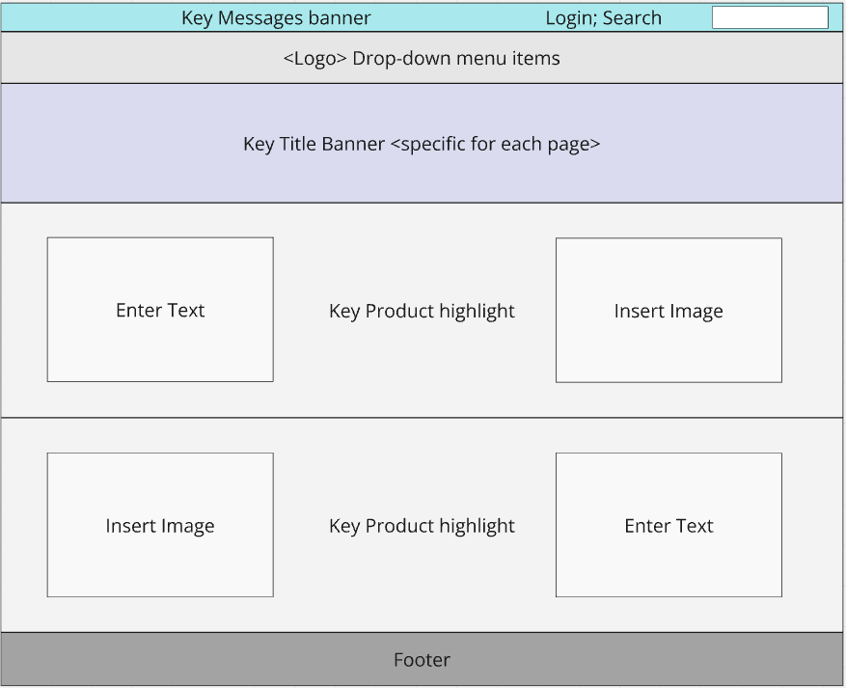

## Membership Registration

Providing several options for registering to the DataConnect Association. The value propositions of the options is clear.

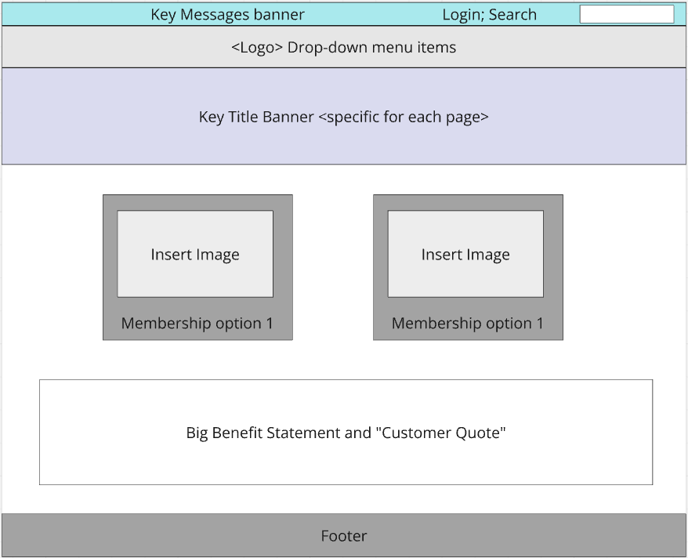

## All Events

Providing a summary of upcoming events, including detailed information and an option to register.

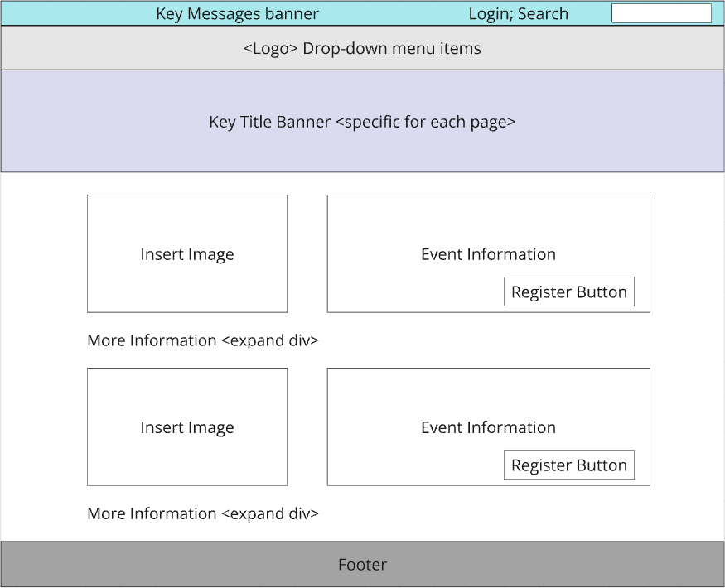

## Articles

Includes a Hero article and a collection of other Data and Analytics related articles relevant to the member base.

## Contact Us Form

An opportunity to provide feedback to the DataConnect association and sign up to weekly email subscriptions.

